EXPERIMENT: Rankine Cycle
OBJECTIVES:
- To determine the Rankine cycle efficiency
APPARATUS:
- Steam motor set
- Stopwatch
- Measuring cylinder
TEORY:
The Rankine cycle is an ideal cycle for comparing the performance of steam plants. It is modified form of Carnot cycle, in which the condensation process (3-4) is continued until the steam is condensed into water. The schematic diagram of a steam engine is shown in figure.
Rankine cycle efficiency = $η_{R}$
$$η_{R}= \frac{h_{B}-h_{F}}{h_{B}-h_{D}}$$
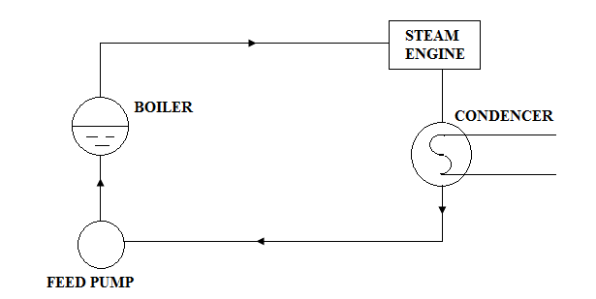
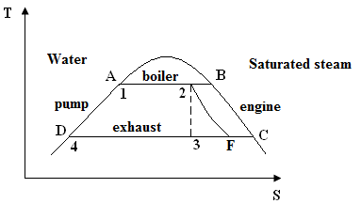
Heat supplied to the boiler;
$q_{in}= \left(h_{2}-h_{1}\right)m_{o}$ Where m_{o} is the steam flow rate
$h_{2}= h_{1}+ \frac{q_{in}}{m_{o}}$ Where h₁ = h_{f} at boiler pressure
Dryness fraction of steam at state 2 is given by
$h_{2}= h_{A}+ x_{2}\left(h_{B}-h_{A}\right)$
$$x_{2}= \frac{h_{2}-h_{A}}{h_{B}-h_{A}}$$
Dryness fraction of steam at state 3;
$s_{2}= s_{A}+ x_{2}\left(s_{B}-s_{A}\right)$
But $s_{2}= s_{3}$
Also $s_{3}= s_{C}+ x_{3}\left(s_{c}- s_{D}\right)$
$$x_{3}= \frac{\left(s_{3}- s_{C}\right)}{\left(s_{D}- s_{C}\right)}$$
Enthalpy of steam at state 3;
$h_{3}= h_{D}+ x_{3}\left(h_{C}- h_{D}\right)$ (h_{D} = h_{f} at atmospheric pressure)

PROCEDURE:
- Fill the boiler before switching on the heaters.
- Lower the spring balance to remove the load from the engine brake.
- When the boiler pressure becomes 60 kN/m² (0.6 bar), open the stop valve until the engine inlet pressure reaches 40 kN/m² (0.4 bar), to 50 kN/m² (0.5 bar).
- Turn the steam motor wheel clockwise.
- Adjust the condenser-cooling water supply to a flow rate of about 100 l/hr.
- Adjust the engine speed to 2000 rpm. Allow the engine to run for at least 10 minutes before taking readings.
- Take necessary readings for different load applied by the spring balance.
- Note down the atmospheric temperature and pressure.

CALCULATIONS:
- Enthalpy of steam leaving the boiler.
- Enthalpy of steam leaving the steam motor.
- Enthalpy of water entering the pump
- Enthalpy of water entering the boiler
- Rankine efficiency of the steam plant.

DISCUSSION:
- Explain the difference between Carnot cycle & Rankine cycle
- Discuss practical errors.

OBSERVATIONS:

EXPERIMENT: DRYNESS FRACTION OF STEAM
EXPERIMENT NO:
ADMISSION NO:

 | Test 01 | Test 02
Boiler pressure (kN/m²)
Watt meter reading
Time taken to collect 100 ml of condensates.

Atmospheric Pressure (bar): ….......................................

