WARNING: The TE5 apparatus uses electricity, water and steam. Some surface will get hot, small amounts of steam vent and some water and oil may drip from the steam engine.

STEAM MOTOR & ENERGY CONVERSION TEST SET
WARNING
This apparatus uses electricity, water and steam. Some surfaces will get hot, small amounts of steam engine. Do not adjust, open or alter any parts of the apparatus other than those described in the experiments, especially when there is hot water or steam in the system.
This apparatus is safe to use, providing that you act sensible and obey normal safety procedures.
Wear eye protection and suitable clothing when using this apparatus.

Important Notes
- Never allow the boiler to run dry.
- Do not rely on safety devices to protect the thermocouples and gauges.
- Water gauges are often temperamental. Check the indication of water level in the boiler frequently by “blowing down” the sight gauge, to do this:
  - Carefully open the sight gauge valve (blow down cock).
  - Allow some water and steam to blow off to waste.
  - Close the valve
There is always the possibility that either the top or bottom connection between the sight gauge and the boiler may become blocked. To check that both connections are free, shut off each of the valves in turn and blow the gauge down.
- The isolator switch (labeled Mains In) will trip if the red emergency stop button is pressed. Protection is also provided against earth leakage and over current faults.
Set-up and Checks
- Connect the cooling water supply to the inlet pipe of the condenser and connect the outlet pipe to a suitable drain. Connect the outlet from the condensate collector to a suitable drain or container.
- Connect the unit to the electrical supply.
- Check the oil levels in the sump of the steam engine, in the water pump and the displacement lubricator.
Note: Water may have inside the displacement lubricator. Drain this out before adding any oil. Hold a rag under the lubricator and undo the small drain cock, when the water has drained out; redo the drain cock.
- Open the displacement lubricator valve quarter to half a turn. This will give approximately 15 minutes of lubrication.
- Check that the filter on the end of the boiler pump pipe is in place and clean. Place the end of the pipe into the reservoir tank supplied. Fill the tank with clean soft water to at least half way. Make sure the reservoir is kept at least half full to ensure no air is drawn in to the pump.
- Open the upper and lower valves on the boiler sight gauge, and the stop valve on the boiler.
- Switch on the temperature display, making sure that the displays work, they will self test with the words: “TQ” and “TE5”.
- Make sure that the red emergency stop button is pulled out. Switch on the mains supply and then the boiler feed pump.
- Open the pump bleed valve and check that the pump is operating. The pump may need priming by lifting up the feed pipe and pouring some water into the pipe. When there is a steady flow of water, with no air bubbles, close the bleed valve and begin to fill the boiler until water is seen in the sight gauge. The boiler should fill in 8 to 10 minutes. When the boiler is full, close the boiler stop valve.
- Slacken the band brake to ensure that the engine is not loaded. Zero the spring balanced.
- Switch on both heaters, the indicator lamps will light up to show the heaters are working. The boiler pressure will rise as indicated on the boiler pressure gauge. Make sure that the calorimeter valve is fully closed.

EXPERIMENT: Dryness Fraction of Steam
OBJECTIVES:
To determine the dryness fraction of steam
APPARATUS:
- Steam motor test set
- Stopwatch
- Measuring cylinder
THEORY:
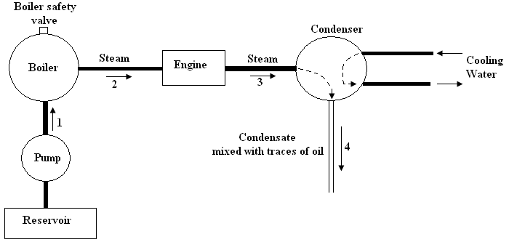
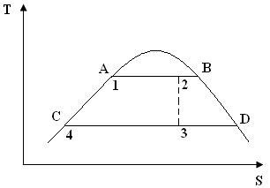
- Dryness fraction of steam at state 2

Heat supplied to the boiler
$q_{in}= \left(h_{2}-h_{1}\right)\dot{m}$ Where $\dot{m}$ is the steam flow rate.
$$h_{2}= h_{1}+ \frac{q_{in}}{\dot{m}}$$
Where $h_{1}= h_{A}$
Dryness fraction of steam at state 2, x₂ is given by,
$$h_{2}= h_{A}+ x_{2}\left(h_{B}- h_{A}\right)$$
$$x_{2}= \frac{h_{2}-h_{A}}{h_{B}-h_{A}}$$

h_{B} and h_{A} can be obtained from steam table (corresponding to the boiler pressure)

- Dryness fraction of steam at state 3

From the expansion of steam in steam motor (assumed to be isentropic) will result a drop in dryness fraction.
$$s_{2}= s_{A}+ x_{2}\left(s_{B}-s_{A}\right)$$
But $s_{2}= s_{3}$
Also $s_{3}= s_{C}+ x_{3}\left(s_{D}-s_{C}\right)$
$$∴ x_{3}= \frac{s_{3}-s_{C}}{s_{D}-s_{C}}$$
s_{A}, s_{B}, s_{C} and s_{D} can be obtained from steam table.

PROCEDURE:
- Fill the boiler by means of feed pump before switching on the heaters.
- Lower the spring balance to remove the load from the engine brake.
- When boiler pressure becomes 60 kN/m² (0.6 bar), open the stop valve until the engine inlet pressure reaches 40 kN/m² to 50 kN/m² (0.4 bar to 0.5 bar).
- Turn the steam motor wheel clockwise.
- Turn on the condenser cooling water supply and adjust it to a flow rate of about 100 l/hr.
- Adjust the engine speed to 2000 rpm. Allow the engine to run for at least 10 minutes before taking readings.
- Take the necessary readings as stated in the observation sheet for different load applied by the spring balance.
- Keep the engine speed constant at 2000 rpm by adjusting the steam flow rate.
- Once the load is changed, allow the engine to run for about 10 minutes to attain steady state.
- Repeat steps 5 – 8 for three different loads.
- Note down the atmospheric temperature and pressure.

CALCULATIONS:
Using the observations you have made, calculate the followings.
- Steam consumption (in kg/hr)
- Enthalpy of steam leaving the boiler
- Dryness fraction of steam leaving the boiler
- Entropy of steam leaving the boiler
- Dryness fraction of steam leaving the steam motor (assume an isentropic expansion)
Tabulate the results.

DISCUSSION:
- Explain the term “dryness fraction”
- Explain the term “isentropic efficiency” and the use of it.

OBSERVATIONS:
EXPERIMENT: DRYNESS FRACTION OF STEAM
EXPERIMENT NO:
ADMISSION NO:

 | LOAD 1 | LOAD 2 | LOAD 3
Boiler pressure (kN/m²)
Boiler temperature (°C)
Watt meter reading
Condensate temperature (°C)
Time taken to collect 100 ml of condensate (s)

Atmospheric pressure (mmHg) =
Atmospheric temperature (°C) =

